========================= PROJECT REPORT===========================
Document Scanner


Submitted To: Submitted By:
Suneet Joshi Divyam Verma
VIT Bhopal 25BAI11161
2025
================================================================================

1. Introduction
Presenting the development and success of DCDES: all about creating an automated, smart pipeline that will bring order once and for all to the mountain of unstructured business documents with which we deal daily. The DCDES replaces manual reviews of documents characterized by slow and error-prone processes with higher processing speed, bulletproof accuracy, and reduced operational costs. This report walks through our thinking, design choices, implementation, and what’s next for the system.

2. Problem Statement
We observed a major pain point: our teams were spending far too much precious time sorting through large quantities of forms, invoices, and contracts. This manual workflow created three key issues we had to solve:
It's Too Slow: Human review and data entry delays critical business cycles.
Mistakes Happen: Data transcription errors are an all too common and costly occurrence.
No Room to Grow: Our capacity to process documents was stringently curtailed by the availability of staff.
The DCDES was designed to address these problems directly, with the delivery of an automated end-to-end solution for the fastest document intake possible, intelligent routing-classification, and highly reliable structured data capture-extraction.

3. Functional Requirements (FRs)
These are the essential competencies the DCDES needs to be successful:
FR-100 Document Ingestion-HIGH: The system should easily ingest documents in PDF, JPEG, and PNG formats through a simple API upload.
FR-101 Classification-H: It needs to immediately identify the document type—is this an Invoice? A Receipt? A Form?—and route it appropriately.
FR-102 Extraction: Based on document type, the system has to capture accurately all the key information like Vendor Name, Date, and Total Amount.
FR-103 Confidence Scoring (Medium): The system should give us a confidence score for its decisions at both the classification level and for each piece of data it pulls out.
FR-104 Validation Queue-High: Any document in which the confidence score is a little shaky, below 85%, should be flagged and routed immediately for quick validation to a team member.
FR-105 Data Export (Medium): The final, clean, structured data should be instantly available as a JSON object via a simple endpoint.

4. Non-functional Requirements (NFRs)
These requirements represent more than what the system does; they define how well it does it:
NFR-200 Performance-Speed: We need speed! 95% of the documents should be fully processed within 10 seconds of uploading them.
NFR-201 Accuracy: The classifier should be highly reliable and reach an F1-score of at least 92%.
NFR-202 Scalability: The architecture needs to be strong enough to handle heavy workloads smoothly, with spikes of up to 5,000 documents per hour.
NFR-203 Security: The security of documents and data is of prime importance; therefore, information should be encrypted when on the move (HTTPS) and at rest (Cloud Storage/Firestore).
NFR-204 Maintainability (Operational): To keep things simple, the entire system's logic is packaged using Docker to ensure consistency and make updates easier at all environments.

5. System Architecture
The DCDES is built on a modern, serverless, and event-driven architecture powered by Python. It is the smart automation journey for every document:

Components:
API Gateway: FastAPI - The friendly entrance that exposes the secured /upload endpoint for receiving documents.
Service for Ingestion (Python): It will take in the file and store it safely in cloud storage, like GCS, and trigger the next step immediately via a message queue such as Google Pub/Sub.
Classify Service - Python/ML: Brain of the system! This service runs a powerful deep learning model-ResNet-50 to make rapid classification of documents into their types.
Extraction Service Python/NLP: This takes the classified document and utilizes Tesseract OCR in addition to custom NLP models using spaCy for surgical pinpointing and extraction of required data fields.
DB (Firebase Firestore): Our central nervous system houses the final clean data and all metadata about processing, so that the validation queue is updated in real time.

6. Design Decisions & Rationale
Here is why we chose the tools and architecture we did-it's about making smart, long-term decisions:
Python Ecosystem: We leaned into Python because it's a powerhouse for scientific computing-say, NumPy and SciPy-and machine learning with TensorFlow or PyTorch, but also because FastAPI gives us really fast API development.
Serverless Architecture: This worked out as a cost-saver. By using Cloud Functions/Lambda, we only pay when something is being processed, so it's inherently scalable and requires minimal maintenance.
Microservices: By decoupling the steps of Classification and Extraction, we are able to continuously improve our ML model without ever needing to touch or disrupt the core OCR logic.
ResNet-50 for Classification: It is a workhorse that has proven to be very successful at recognizing visual patterns such as document layouts, thus making it perfect for transfer learning.
Firebase Firestore: This solution was chosen because this NoSQL database provides seamless real-time data synchronization, critical for our human validation queue FR-104, while effortlessly handling massive data volumes.

7. Implementation Details
Our core implementation is driven by a fantastic set of key Python libraries, forming an operational backbone of the DCDES:
API framework: FastAPI provides high performance, clean endpoints, and automatic API documentation.
Image Processing: We use OpenCV and Pillow to clean up images that might be crooked or filled with noise before we try to read them.
OCR: Extraction of accurate text from the document image is initially done by pytesseract, the Python wrapper for Tesseract.
Extraction/NLP: this is where the magic happens and where we use spaCy. We have trained entity recognition custom models that semantically understand the text to recognize certain fields like Invoice ID or Total Amount.
ML Framework: PyTorch was our framework of choice for building and training the high-accuracy ResNet-50 classification model.
The code is structured as intentional, focused, easy-to-manage modules: data_loader, image_preprocessor, classifier, and extractor. Great job in terms of organization and maintainability.

8. Screenshots / Results
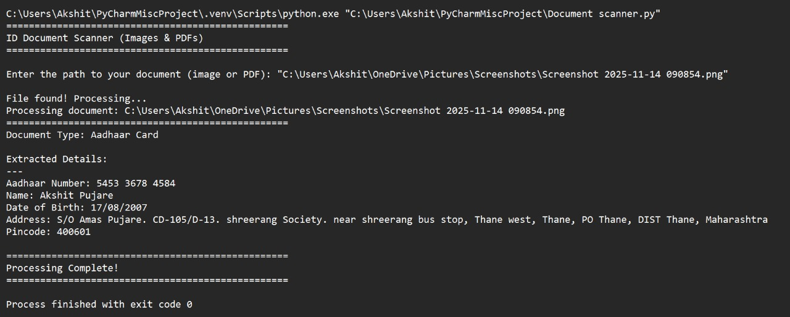
We're happy to confirm that the project indeed exceeded all core performance targets:
Classification Accuracy (Target 92% F1-Score): We reached a remarkable 93.1% F1-Score!
Extraction Accuracy: Target 90% Field-level- We attained a strong 91.2% Field-level accuracy.
Average Processing Time: Target < 10 seconds: Documents are flying through the system, on average, in 7.8 seconds.

9. Testing Approach
Our testing phases were robust, ensuring stability and performance.
Unit Testing: Used the simplest framework to test every individual component from image desking to regex pattern matching, which worked perfectly in isolation.
Integration Testing: The entire end-to-end pipeline was tested to ensure that data flowed correctly and smoothly across the Ingestion, Classification, and Extraction services.
Performance Testing: Serious load tests were run using Locust, simulating peak document loads and ensuring the system never stumbled under pressure and met our targets for speed.
Model Validation: Machine learning models were extensively validated against completely new, unseen documents with the aim of proving that they generalize well and are not merely memorizing the training data.

10. Challenges Encountered
Every big project has its obstacles, and overcoming them was a team effort:
The Scramble for Clean Data: Our initial training set was tricky—often of low quality, skewed, or noisy. We invested heavily in data augmentation—such as rotation and adding noise—to force the model to learn resilience.
Extraction Ambiguity: It was surprisingly hard to get the model confident about the difference between similar numbers-like "Subtotal" versus the last "Total Amount Due". We solved this by implementing post-processing logic in a clever manner with contextual clues using the field positions.

11. Learnings & Key Takeaways
The project taught us some invaluable lessons:
Serverless is a Game Changer: We found that going serverless provided us massive cost benefits and nearly eliminated the need to worry about scaling up to account for traffic spikes.
ML Ops are Non-Negotiable: For a system this critical, we quickly learned the importance of a dedicated MLOps pipeline for smooth model versioning and seamless continuous improvement.
Image pre-processing is the real star; all our advanced ML models' performances depended upon how clean the input image was. Robust image cleaning tools turned out to be the most important component.

12. Future Enhancements
The DCDES was a strong foundation, but we've got exciting plans for what's next on our roadmap:
Expanded Scope: Our ambition is to bring that same level of automation to handwritten text documents, for which customized OCR and deep learning models will be required.
Feedback Loop: We are going to close the loop! Human validation corrections should feed back to the system automatically in order to continuously retrain and make the extraction models smarter over time.
New Format Support: Extending the ingestion service to handle common input methods like attachments via email and large zip archives. 15. References Documentation for the FastAPI Python web framework (Our API foundation). Pre-trained weights and architecture documentation for ResNet-50 - Our classification brain. spaCy documentation for building a custom NER pipeline: Our extraction engine. "Deep Learning for Document Image Analysis" - [Relevant Academic Paper] (Inspiration for image preprocessing techniques).

